**LAPORAN 2 INSTALASI REDIS**

Disusun untuk memenuhi tugas mata kuliah Topik Khusus Dosen Pengampu: Mutia Rahmi Dewi, S.Kom., M.Kom



Oleh

**ERFAN FADHIL JUZAR  
 NIM. 2211082006**

**PROGRAM STUDI TEKNOLOGI REKAYASA PERANGKAT LUNAK JURUSAN TEKNOLOGI INFORMASI**

**POLITEKNIK NEGERI PADANG 2025**

1. Aktifkan Redis di laragon

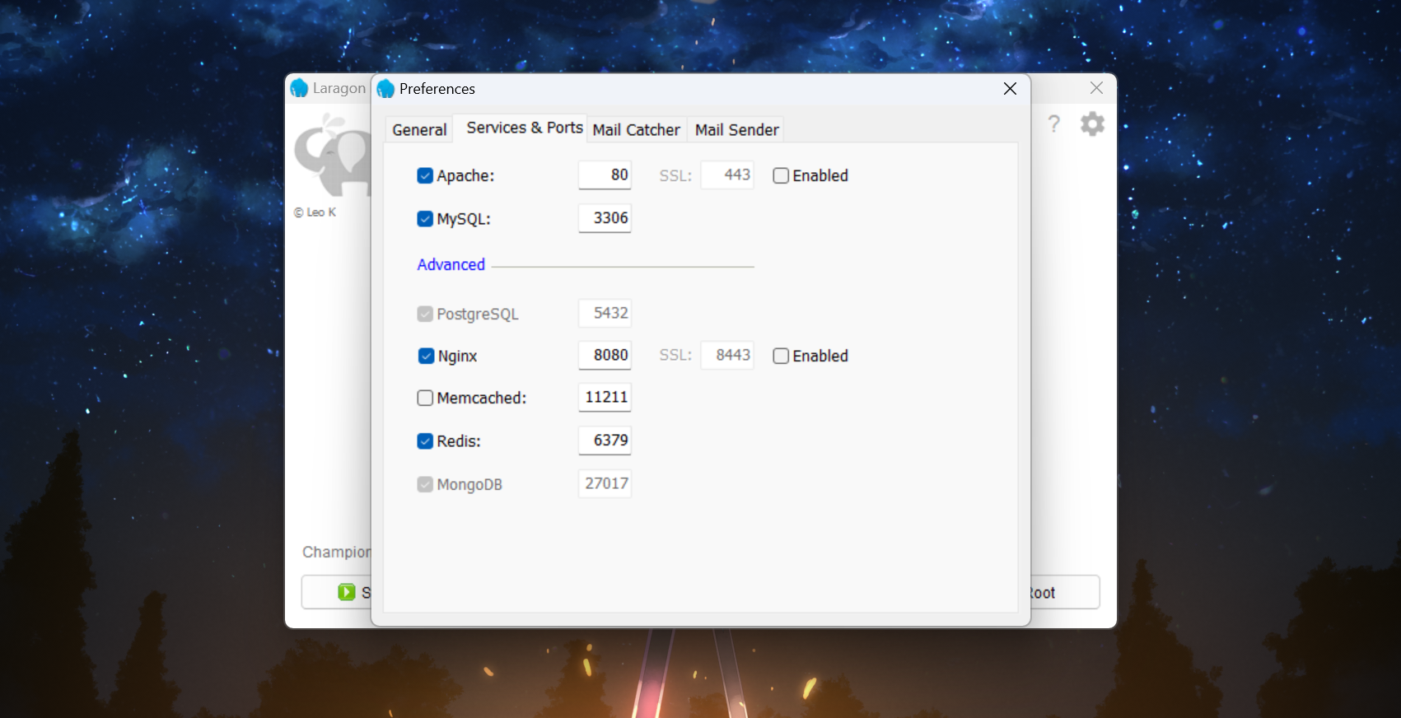

1. Jalankan Redis

1. Setup database dan Bikin Table baru

1. Setup nama database

1. Install dependencies

1. Jalankan Server

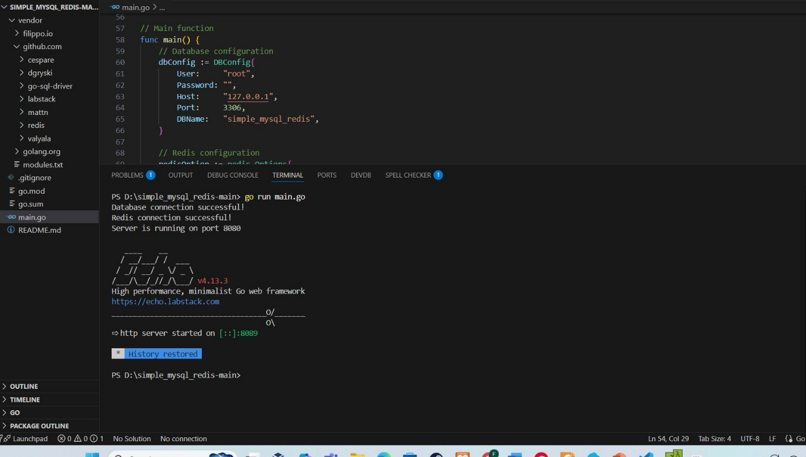

**API ENDPOINT:**

1. Create User

1. Get ALL user

1. Get Single User

1. Update User

1. Delete User

